Python deployment on Windows IIS Server
Step 1: Install Python:
- Download web installer from https://www.python.org/downloads/
- Run as Administrator.
- Select custom installation for all users.
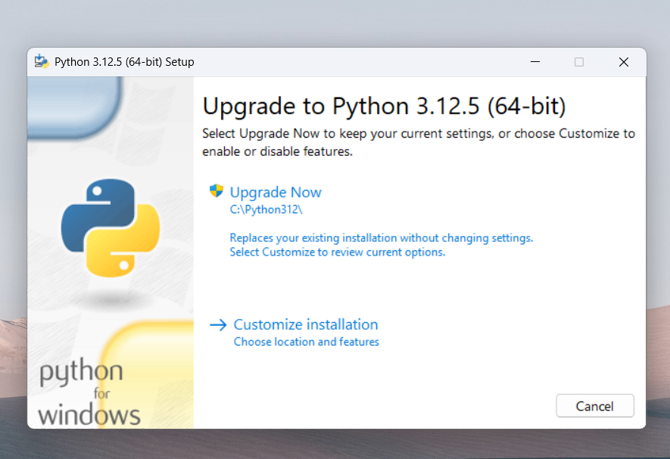
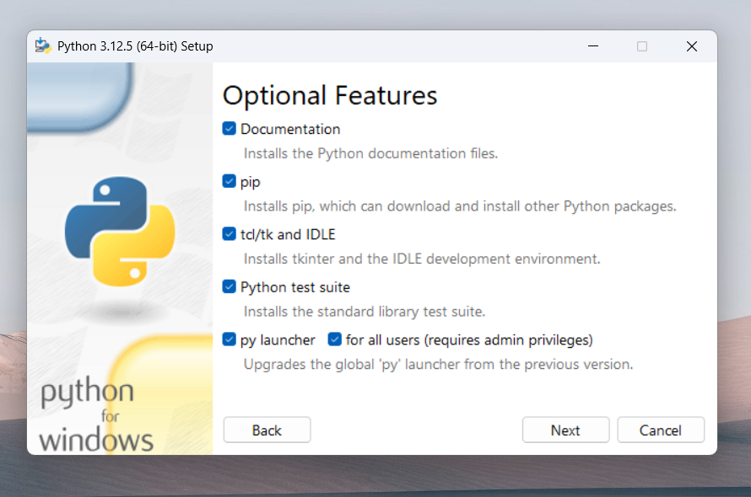

- Choose install directory such that there are no white spaces in the path.
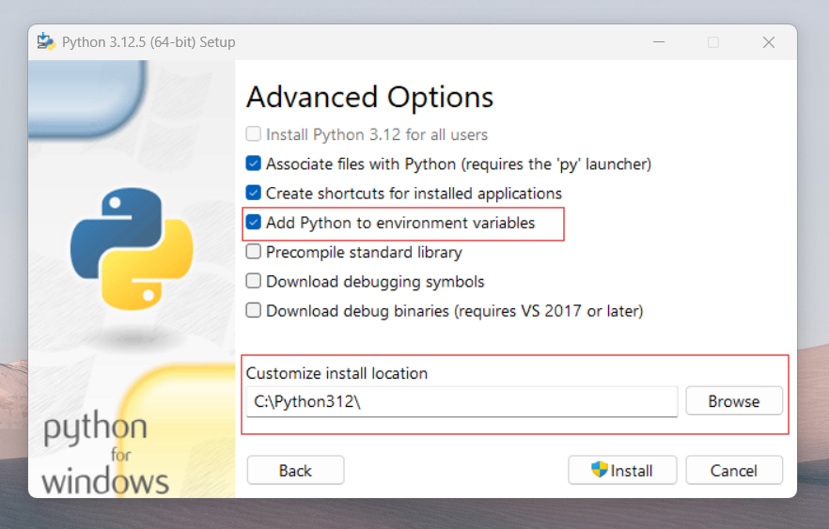
- Check the box for "Add Python to PATH/environment variables".
- After installation is completed, please ensure that the environment variables are added to the PATH.
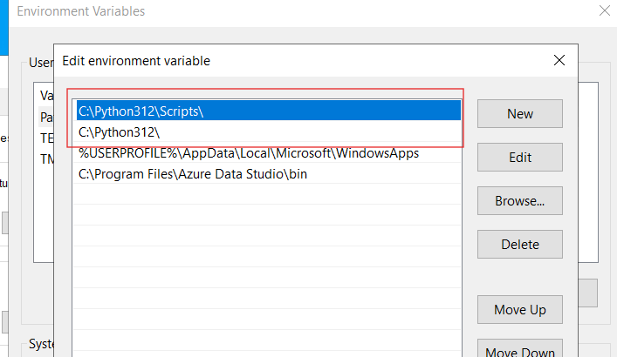

Step 2: Install wfastcgi
- Open Windows Powershell as Administrator. Go to project directory and run command “pip install -r requirements.txt” to install all the required extensions used for that project.
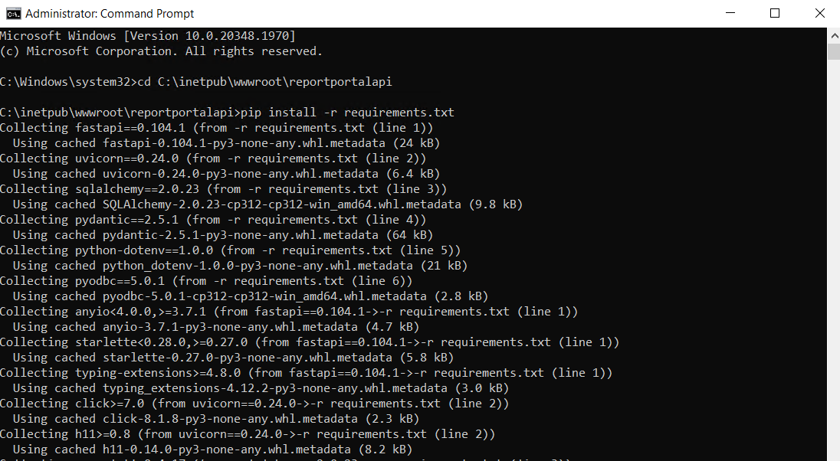

- Configuring IIS:
Install the Web Server Gateway Interface (WSGI)
To run Fast API on IIS, you need to use a WSGI server. Install wfastcgi using pip.
in the terminal run command “pip install wfastcgi”
and then enable it.
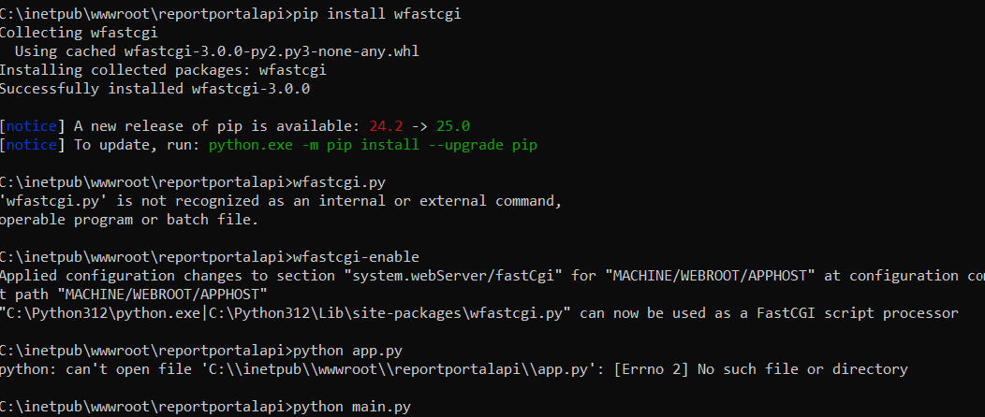

Step 3: Configure Website/Application in IIS
- Open IIS Manager: Launch IIS Manager on your server.
- Add a New Site: Right-click on 'Sites' and select 'Add Website'. Fill in the site name, physical path to your FastAPI /Python application, and the port number.
Step 4: Configure IIS Application settings
- Click on the server’s name on left side panel in IIS.
- On RHS, go to Application settings option.
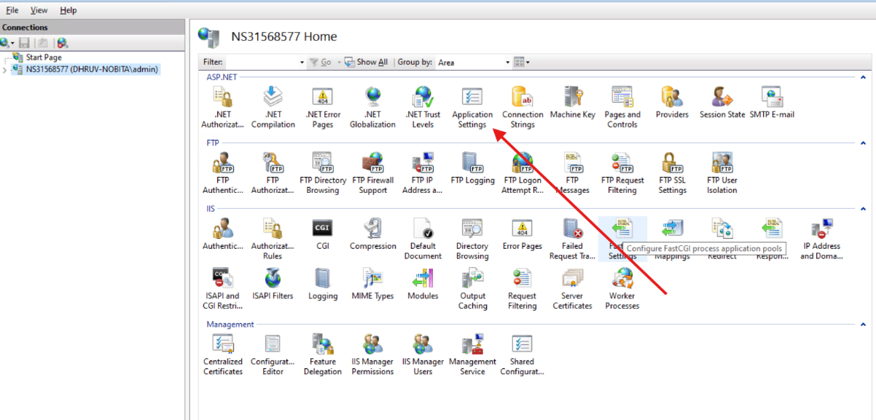
- Add “PYTHONPATH” and “WSGI_HANDLER” as two entries.
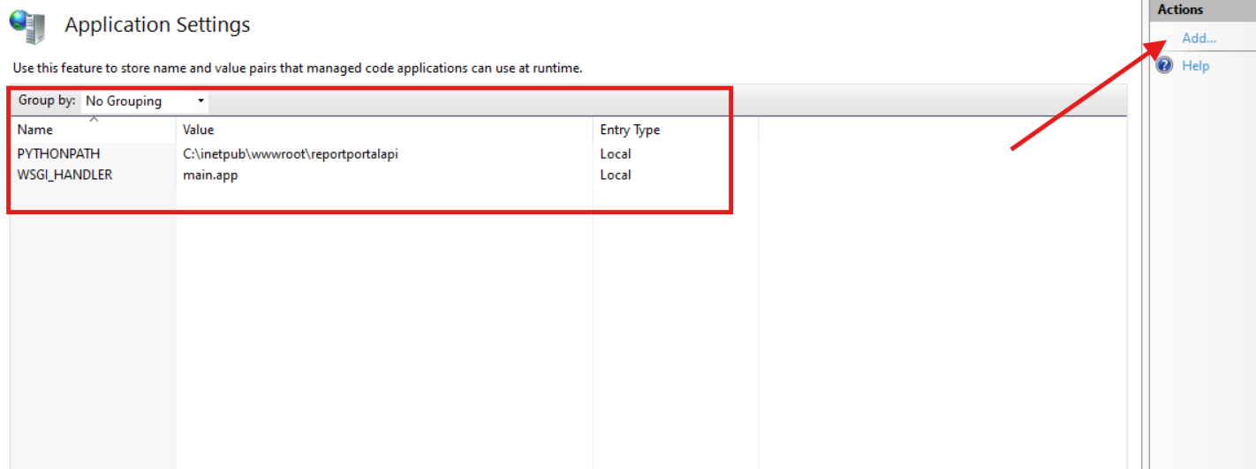

Step 5: Configure Fast CGI Settings
In the site settings, go to 'Handler Mappings' and add a new module mapping
- Request path: *
- Module: FastCgiModule
- Executable: Path to your Python executable (e.g., C:\Python312\python.exe)
- Name: Python Fast API
- Set Environment Variables: In the Fast CGI settings, set the environment variable WSGI_HANDLER to your application’s entry point, for example, main:app.
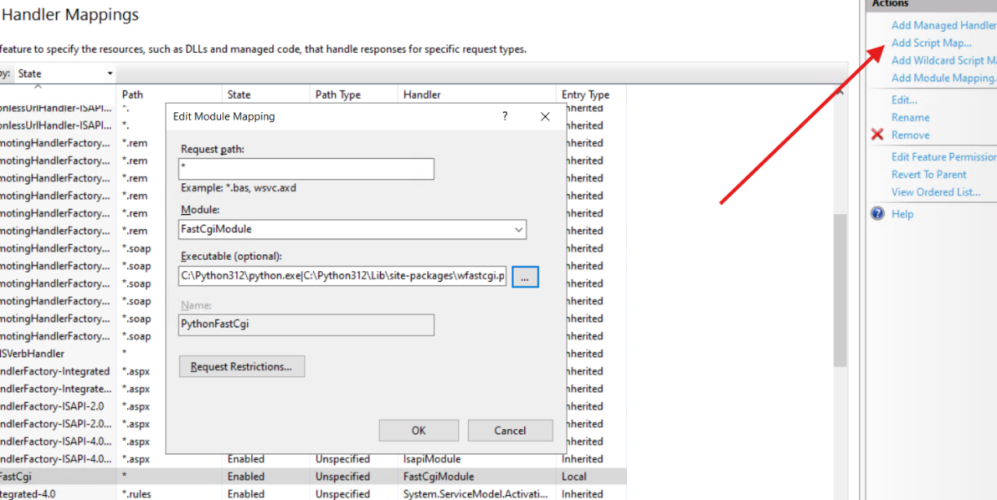

After adding the above setting, your application’s web.config will look something like this:
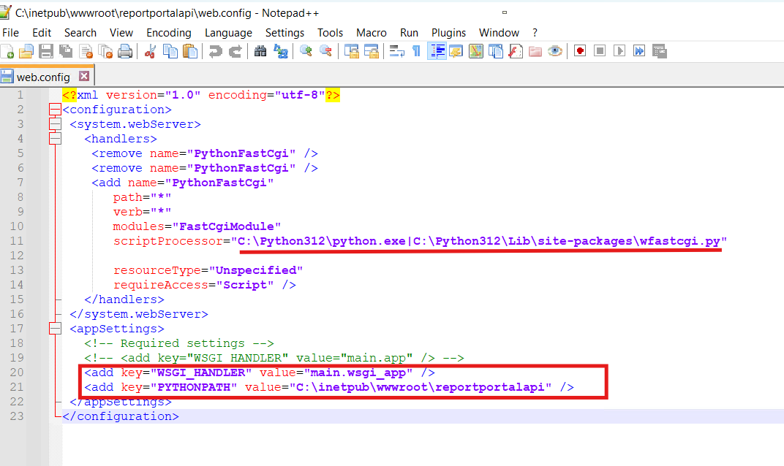

Step 6: Configure Application Pool Settings
- Create a New Application Pool: Right-click on 'Application Pools' and select 'Add Application Pool'. Set the .NET CLR version to 'No Managed Code'.
- Assign the Application Pool: Assign the newly created application pool to your Fast API/Python site.
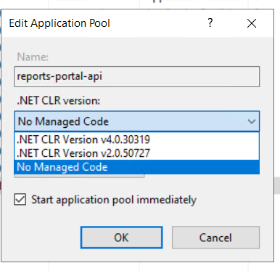
- You might have to restart the the website after configuration changes. Option will be under Actions on the right.
- You can browse your URL into the browser.

